GPS Speed meter: G1

Warning: This product working voltage is 5V, and it is forbidden to use a voltage higher than 5V for power supply.

Display functions:

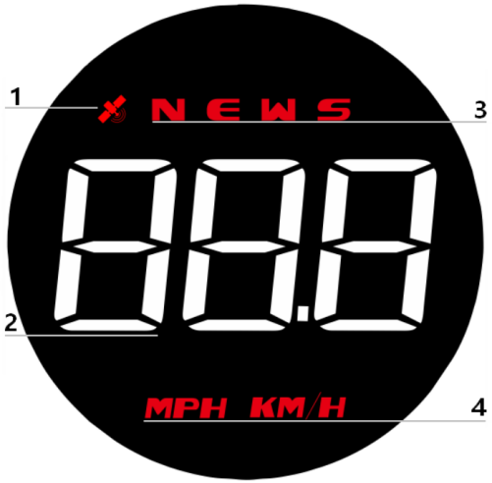

- Satellite icon: After the satellite is found, the GPS light stops flashing and stays on for normal use.
2. Vehicle speed display
3. Compass: N (North) E (East) W (West) S (South)
4. Speed unit: KM/H (kilometers) MPH (miles)

Wave button function

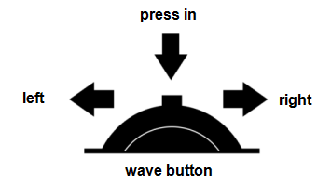

1.Short press in: confirm the option after entering the setting menu
2.long press in: enter the setting, after adjusting, press vertically for 2 seconds to save and exit
3.Push left: move options after entering setting
4.Long push left: push left for 2 seconds to turn off the buzzer alarm, do it again to turn on
5.Push right: switch between concise mode and standard mode, move option after entering setting

Enter setting mode:
Long press in to enter into the setting mode, press right to choose the menu, and short press in to confirm. Once finishing the setting, long press in to exit.
menu | Function Parameters | Adjustment range | Explanation | Default value | Set parameter value interface
 | speed | 50-150 | Adjust the parameter value when there is an error between HUD and dashboard. Ex: dashboard displays 100 KM/H, HUD displays 105 KM/H. Please adjust the parameter value to 102.(107-5) | 107 | 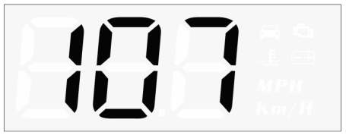
 | Over speed alarm | 30-250 | When the vehicle speed reach to 150, HUD will give the alarm | 150 | 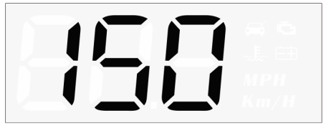
 | Fatigue driving alarm | 1.0-8.0 | HUD will give fatigue driving alarm each 4 hours | 4.0 | 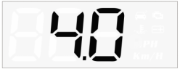
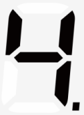 | Brightness adjustment | 0-11 | 0=automatic sensitivity adjustment  1-11=manual adjustment  1=darkest, 11=brightest  1→11 is increasing | 0 | 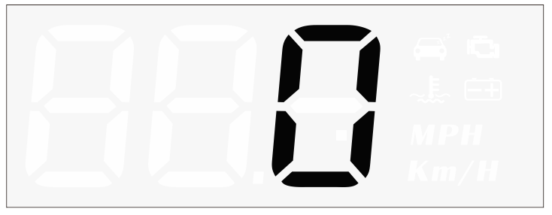
 | Speed unit | 0-1 | 0=KM/H (kilometers)  1=MPH (miles) | 0
 | Factory reset | 0-1 | default=0,  →1, long press in for 3 seconds to save and exit | 0

Troubleshooting

1.The screen without any display, and no power
Check whether the USB cable is damaged, replace the USB cable for testing, and prohibit the use of voltage higher than 5V for power supply

2.Without car Speed
After HUD power-on, the satellite icon flashes will start to find the satellite. Please driving the car to the road. It will work after it stops flashing

3.Inaccurate Speed
a.First check the speed unit is correct or not, the speed unit including KM/H and MPH, please refer to the setting to switch the unit.
b.The car manufacturers usually make the dashboard speed 5-7% higher than the ECU. The international standard is based on satellite data.
(if the dashboard shows 100, and the device shows the 105, change the default value at 102)

4.Driving direction display error
After the vehicle speed exceeds 5KM / H, the direction can be displayed normally.

5. Speed is still displayed after the car stops
Under the underground parking lot, tunnel, under the overpass, there will be unstable satellite drift when there is obstruction.

6.Turn off the buzzer
Push left for 2 seconds to turn off the buzzer, do it again to turn on.

